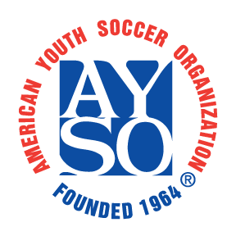

PHOTO RELEASE AGREEMENT

I,________________________, the undersigned, hereby give the American Youth Soccer Organization (AYSO) (REGION XX), the right to use photos taken of my child(ren) during AYSO events to be posted to AYSO (REGION XX) website and social media.
AYSO (REGION XX) will follow AYSO’s Social Media policy that states: “Pictures posted on public sites should not include the names of individual players to avoid identifying children to the wrong individuals. Team rosters with names, numbers and contact information will not be posted on any public website or social media page.”

Parent/Guardian: (please print)
________________________________________________________
Signature: __________________________________________________________
Date: ___________________

10/19/18

