How to prepare
Fiscal Year 7/1/2020 – 6/30/2021 Region Financial Statements
- Ensure Divvy transactions have been categorized
  - Click here to watch a video on How to Export Divvy Transactions and then import to Zipbooks, QuickBooks, Quicken, etc.
  - Balance sheet at month end 6/30/2021 should have a Divvy Credit Card Account balance that equals the amount paid to Divvy at the beginning of July (less any pre-payments, if applicable).
- Zipbooks users and those using the AYSO standard chart of accounts
  - Refer to the Region Financial Statement Template.xlsx for AYSO standard accounts
  - Zipbooks Users:
    - Export Trial balance
    - Zipbooks > Reports > Trial Balance >
    - Set Start/End Dates as 07/01/2020 to 06/30/2021
    - Click Export (top right corner)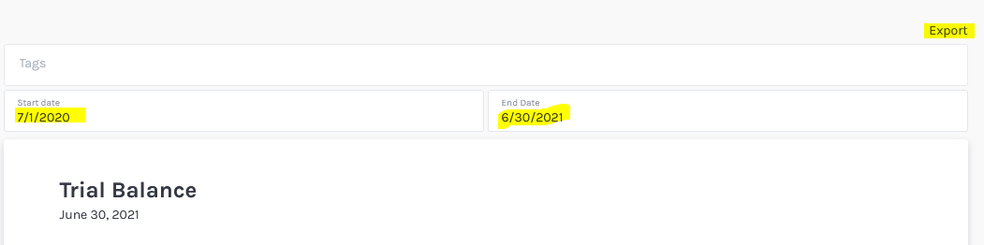
    - Email the TrialBalance.csv file to finance@ayso.org
  - Other Software users (QuickBooks, Quicken, etc.):
    - Run a trial balance if available with dates 07/01/2020 to 06/30/2021
    - If not, then we will need both the income statement and the balance sheet.
    - Set the dates to coincide with the fiscal year 07/01/2020 to 06/30/2021
    - If the software only produces a PDF report, then please proceed to step 3 to transfer into an Excel document.
- Regions using nonstandard chart of accounts follow the instructions below:
  - Run a trial balance or income statement and balance sheet
    - Set dates in your software to our fiscal year 07/01/2020 to 06/30/2021
  - Transfer data onto the Region Financial Statement Template.xlsx we have provided.
    - Choose the best account that closely matches your expense accounts and provide the ending balance for the period.
    - Review for accuracy
    - Send to finance@ayso.org

