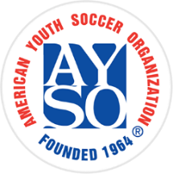

BECOME AN

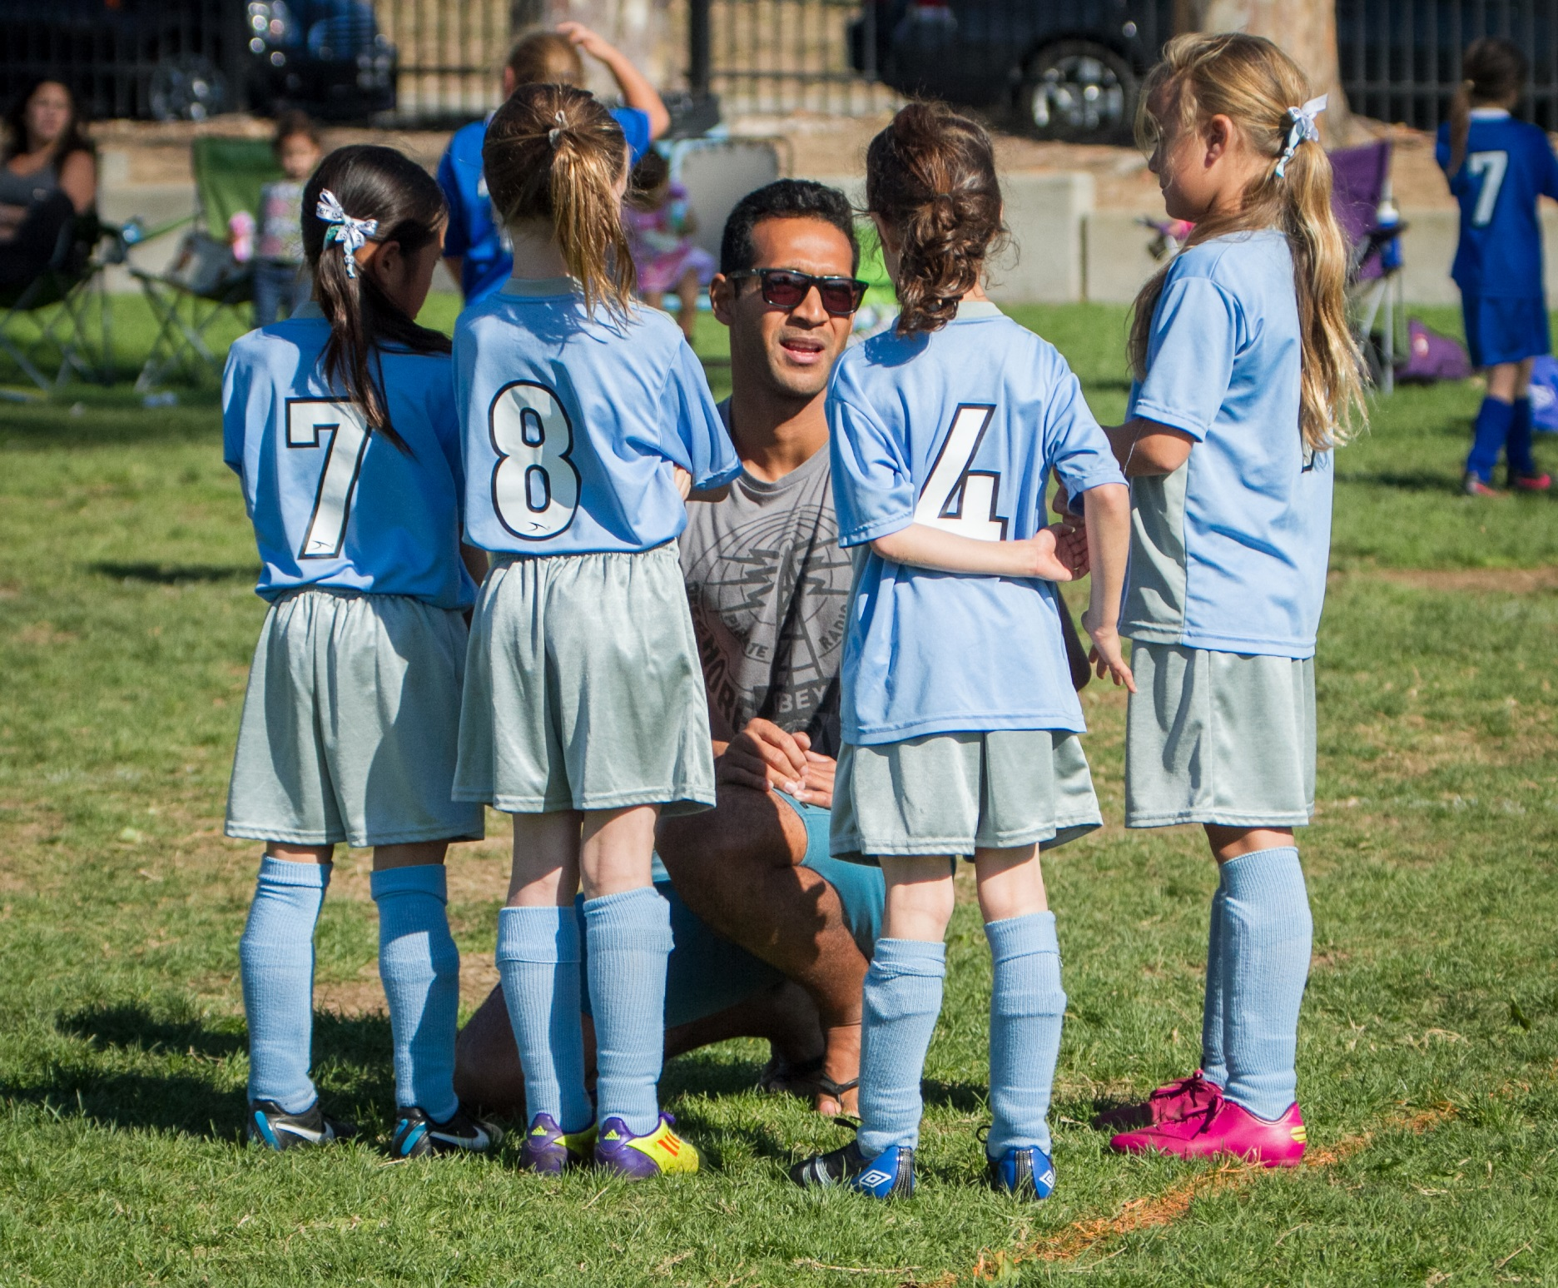

Contact us today at: 555-123-4567 or [inbox@email.com](mailto:inbox@email.com) for more information.

Coaches and Referees needed!

We’ll teach you everything you need to know!

Help make a positive impact in the lives of kids in your community by becoming an AYSO volunteer this season!

Everyone Plays® | Balanced Teams | Open RegistrationPositive Coaching | Good Sportsmanship | Player Development

NO EXPERIENCE

NECESSARY

AYSO VOLUNTEER TODAY