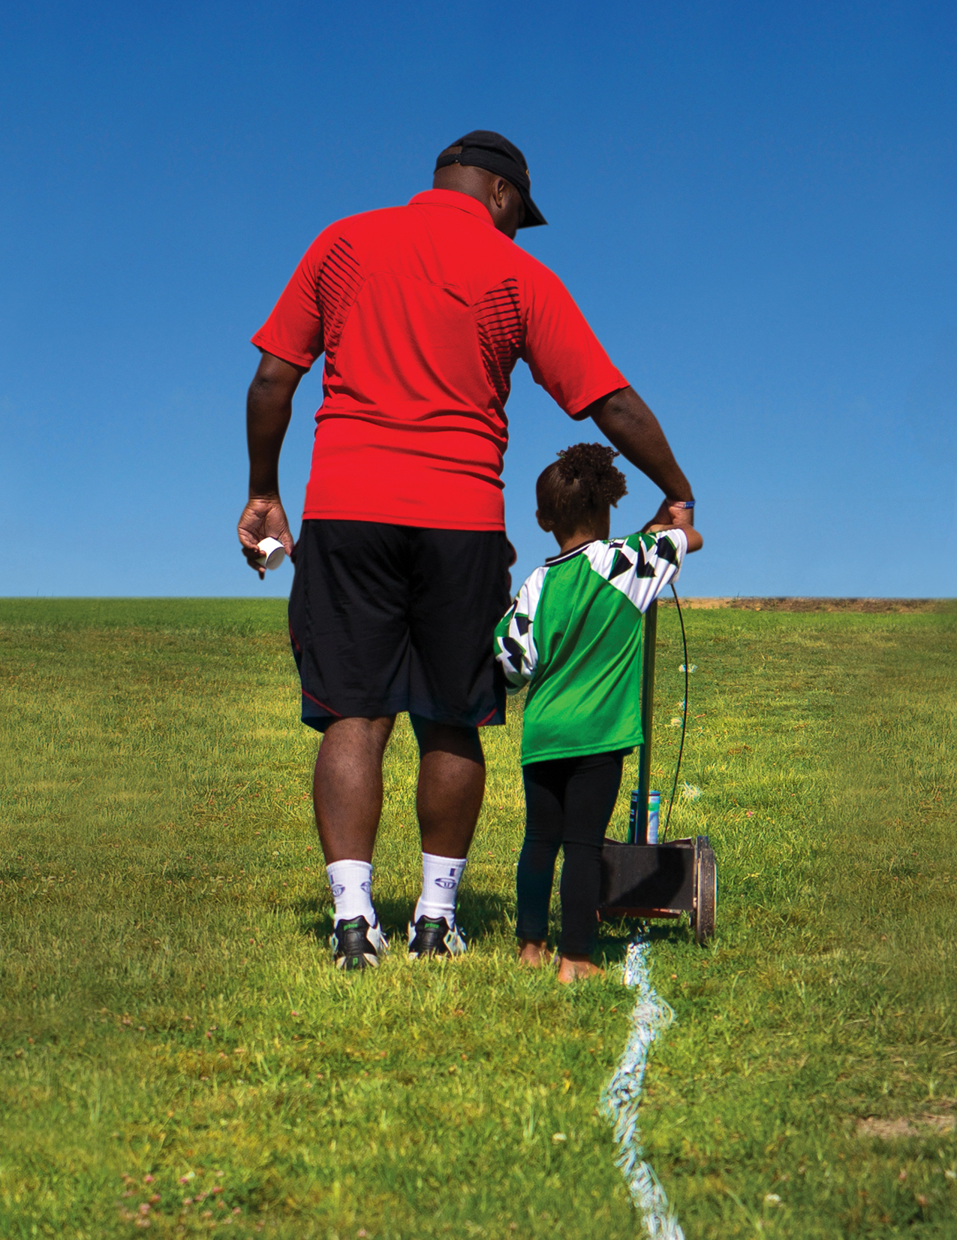

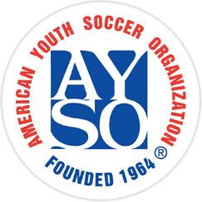

Coaches and Referees needed!

We’ll teach you everything you need to know!

Contact us today at:  
555-123-4567 or [inbox@email.com](mailto:inbox@email.com) for more information.

Help make a positive impact in the lives of kids in your community by becoming an AYSO volunteer this season!

BECOME AN AYSO

VOLUNTEER TODAY!

Everyone Plays® | Balanced Teams  
Open Registration | Positive Coaching Good Sportsmanship | Player Development

NO EXPERIENCE

NECESSARY!

BECOME AN

AYSO VOLUNTEER TODAY

BECOME AN

AYSO VOLUNTEER TODAY