Dear AYSO Region XX Coach,

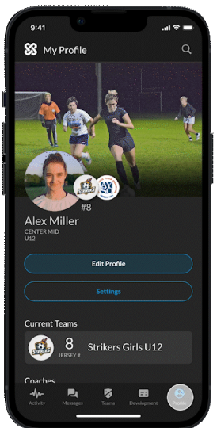
We are excited to announce that AYSO has a new partnership with JUNGO that extends the AYSO experience to a mobile app. This season, we have volunteered to be part of the pilot program of the AYSO+JUNGO app, specifically designed for AYSO Regions, proactively connecting players, parents, coaches, and the Region in a real-time feedback and player development loop, with the goal of improving the overall experience for our families and help them fall deeper in love with the game.

Your participation is key in this pilot program for the fall, as your feedback will help ensure this is engaging, helpful and ultimately making your coaching experience enjoyable and effective.

To that point, I, along with AYSO and JUNGO, want to invite you to a live app demo webinar to explain how you will be an important part of this process. Below is a list of important dates for you to be aware of.

- September 19 - The new AYSO+JUNGO app will be available for download.
  - Download the app and set-up your free profile – available on iOS and Google App Store.
- September 20 and 21 - AYSO+JUNGO will host live demo webinars for all coaches and administrators. RSVP is required.
  - Tuesday, September 20, 2022 at 5:00 p.m. PST
  - Wednesday, September 21, 2022 at 5:00 p.m. PST
- September 30 - All coaches should have the app downloaded and they profile set-up.

Please visit the AYSO+JUNGO landing page on AYSO Volunteers to find:
  - Information on the partnership
  - Link to download the app for iOS and Google App Store
  - How-To videos on how to set-up your profile and much more
  - FAQs

Once you have set-up your profile, you will invite your players and families to download the app and engage in the post-event feedback. You can find that customizable email template here. This feedback will provide you with valuable information that supports your coaching journey and team interactions.

If you have questions about Jungo, please contact our JUNGO partners through the app or via Contact+AYSO@jungo-sports.com. (RC can add their contact info here as well).

Thank you in advance for your participation in this pilot group. See you on the webinars!

Best,

