Dear AYSO TEAM NAME TEAM MEMBER,

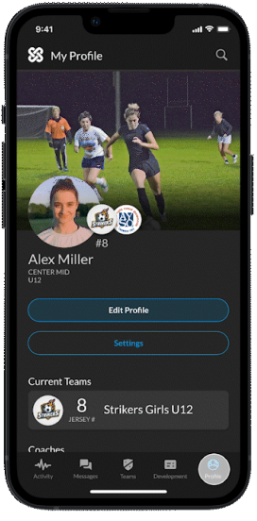
I am so happy to be your coach this fall season, and look forward to a fun and exciting time for you and your child alike. AYSO has collaborated with Jungo Sports to develop a new mobile-app tool that will help us stay connected throughout the season, allowing us to create a positive soccer experience for all. Our Region is one of the lucky few that get to take part in the pilot program, so your participation will be invaluable.

So, what do you need to do? Follow the easy steps below to get started!
- Visit the AYSO+JUNGO landing page where you will find:
  - A link to Download the app for iOS or Google App Store.
  - Information on the partnership
  - How-To videos
  - FAQs
- Once you’ve downloaded the app and learned a bit more about it, please:
  - Set-up your free profile - One for you and one for your player.
  - Add me as your coach (ADD Name of Coach Here).
  - Look for an invite from me to add to Team Profile.
- After you are all set-up, you will:
  - Provide feedback to me after games/events to help me keep a pulse on how you and your child are enjoying the experience.
  - Check the team calendar and feed for updates and information.
  - Communicate with me on any questions or concerns you have throughout the season.

As part of this relationship, your feedback and engagement are valuable information that will ensure that this app is a useful tool for me, you, your player, and the Region in creating a fun season for all. Ultimately, you will be a part of shaping the AYSO experience for us and AYSO beyond our Region.

Thank you for being a part of this program and if you have any questions about any of the above, please feel free to contact me and if you have questions about Jungo, while using the app, please contact them through the app or via Contact+AYSO@jungo-sports.com.

Here’s to a great Fall season!

Best,
INSERT COACH NAME

